**ASSIGNMENT : LAB 02**

**SUBJECT : Object Oriented Programming**

**ROLL NO : 24BSAI29**

**SUBMITTED BY : Syed Muhammad Qasim**

**SUBMITTED TO : Ms. Mehwish shaikh**

Mehran University of Engineering and Technology Jamshoro

Name: Syed Muhammad Qasim Roll No: 24BSAI29

Score: Signature of the Lab Tutor: Date: 15 JAN 2024



**Variables and Data Types**

|  |  |  |  |  |  |  |  |
| --- | --- | --- | --- | --- | --- | --- | --- |
| **LAB PERFORMANCE INDICATOR** | **SUBJECT KNOWLEDGE** | **DATA ANALYSIS AND INTERPRETATION** | **ABILITY TO CONDUCT EXPERIMENT** | **PRESENTATION** | **CALCULATION AND CODING** | **OBSERVATION/ RESULTS** | **SCORE** |
| **OBJECTIVE NO:** |  |  |  |  |  |  |  |

**Objectives:**

**Variables and Data Types**

**Tools**

* Notepad++/Eclipse/IntelliJ Idea

|  |  |
| --- | --- |
| **Keywords:** Java, Platform Independent ,JDK,JRE,JVM | **Duration:** 03 hours |

**Lab Exercise:**

1. Task of access modifier.

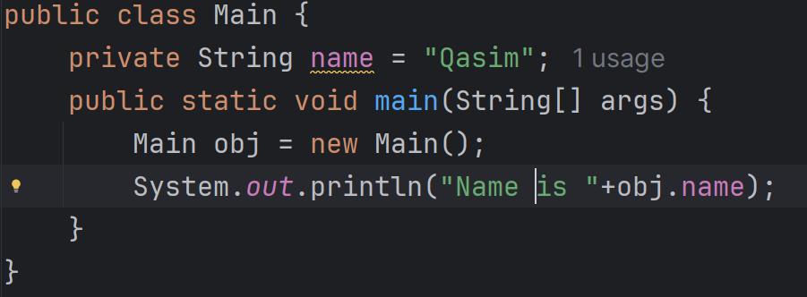

**Result:**

1. Print student information by storing in variables and printing that variables.

**Result:**

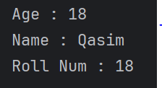

1. Declare and initialize an integer variable with a value of 25 and a double variable with a value of 10.5. Display their values.

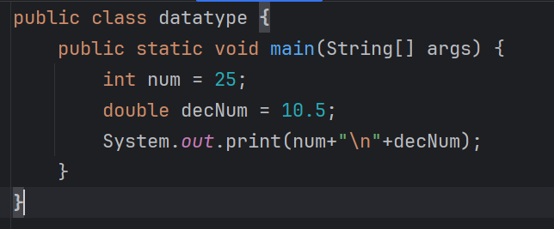

**Result:**

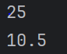

1. Declare a character variable with the letter 'J' and a boolean variable with the value **true**. Print both values.

**Result:**

1. Create two float variables, assign them values, and calculate their sum. Print the result.

**Result:**

1. Declare a String variable with your name and concatenate it with another String **" is learning Java."**. Print the final message.

**Result:**

